Database Systems

Digital Art Gallery and Auction Platform

Andrew Bala Abhilash Polisetty (001138913)
Siri Yellu (001165833)
Keerthana Mandava (001138885)
Baby Naga Venkata Uttara Mekala (001142228)
__________________________________________

Table of Contents
Executive Overview | Page 3
ER Diagram | Page 4
Relational Schema | Page 4
Data Dictionary | Page 5
CRUD Matrix | Page 6
Table Descriptions | Page 6
Database Tables | Page 7-9
Design Tables | Page 10-12
Forms | Page 13-15
Queries | Page 16-17
References and Citations | Page 18

Executive Overview
Primary Objective: The objective of our project is to develop a Digital Art Gallery and Auction Platform that manages digital artwork inventory, bids, auctions, transactions, and user information. Our system allows artists to easily upload their artwork, buyers to place bids in auctions, administrators to manage transactions, and users. This system provides an efficient way to manage artwork, track bids, and process sales.
Client: Digital Art Gallery And Auction Platform
Overview: An ER Diagram is drawn with the usage of IE Crow's Foot symbols, defining the relation between the entities, Transactions, Auctions, Users, Bids, and Artwork. Relational Schema is implemented with the help of MS Access, making sure Primary keys and Foreign keys are present and maintaining data consistency. Records will be subjected to CRUD, allowing users to create, read, update, or delete records within each table.
These features provide efficient management of digital art and auctions, providing real-time reports on artwork, auctions, and transactions. Our system enhances customer experience and supports the growth of the digital art marketplace

Entity-Relationship Diagram
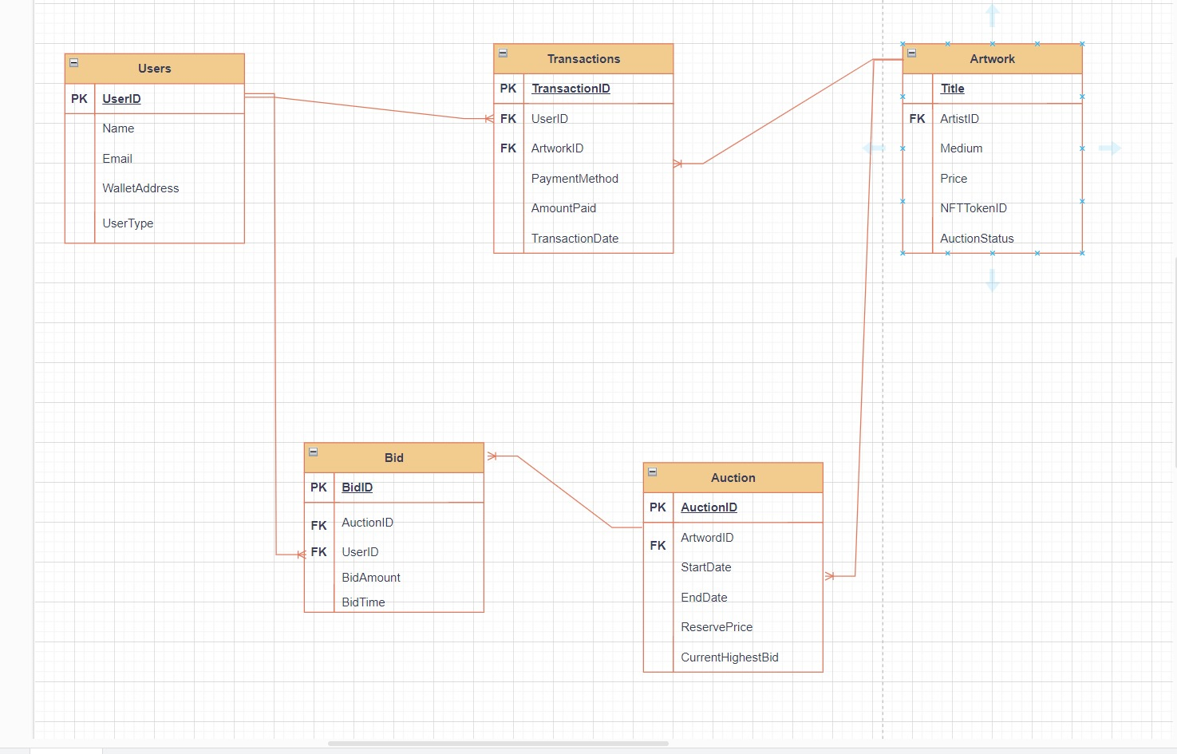

Relational Schema
- Users (UserID [PK], Name, Email, WalletAddress, UserType)

- Artwork (ArtworkID [PK], Title, ArtistID [FK], Medium, Price, NFTTokenID, AuctionStatus)

- Auction (AuctionID [PK], ArtworkID [FK], StartDate, EndDate, ReservePrice, CurrentHighestBid)

- Bid (BidID [PK], AuctionID [FK], UserID [FK], BidAmount, BidTime)

- Transactions (TransactionID [PK], UserID [FK], ArtworkID [FK], PaymentMethod, AmountPaid, TransactionDate)

- Primary Keys (PK) and Foreign Keys (FK) are used to ensure referential integrity between tables.

Data Dictionary

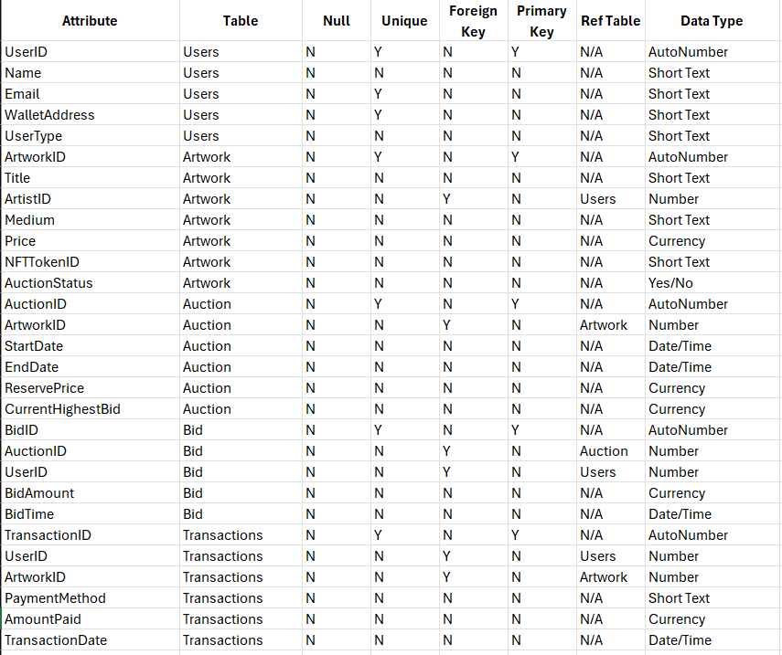

CRUD Matrix

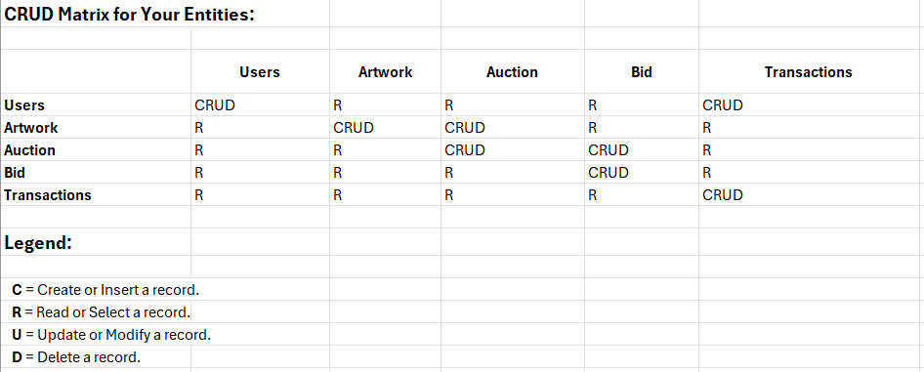

Table Description
- User Table: Contains 10 records, which include artists, buyers, and administrators.
It has attributes such as Name, Email, WalletAddress, and UserType.

- Artwork Table: It has 10 entries of digital artwork. Each ArtworkID has a unique ArtworkID and other attributes like Title, ArtistID, Medium, Price, NFTTokenID, and AuctionStatus.

- Auction Table: It has 10 entries of auctions, each tied to a specific artwork. Each AuctionID is unique for each auction and other attributes like StartDate, EndDate, ReservePrice, and CurrentHighestBid.

- Bid Table: It links the AuctionID from the auction table and UserID from the Users table with the BidAmount and BidTime. This particular table has 10 records showcasing bids placed by users.

- Transactions Table: Contains 10 records of transactions completed for the sale of artwork. Each transaction is uniquely identified by TransactionID and includes references to the UserID (buyer), ArtworkID, PaymentMethod, AmountPaid, and TransactionDate.
Database Tables

Artwork Datasheet:

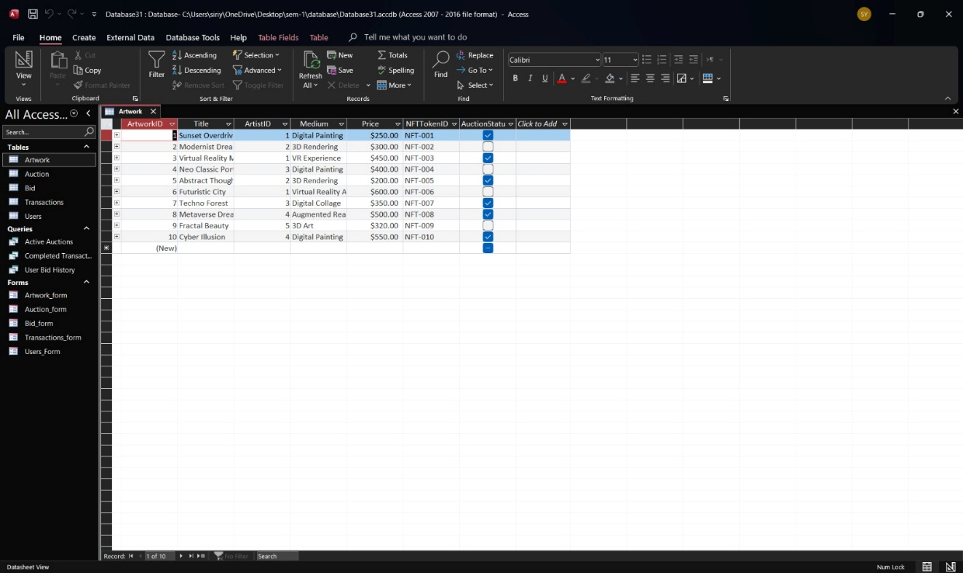
Auction Datasheet:

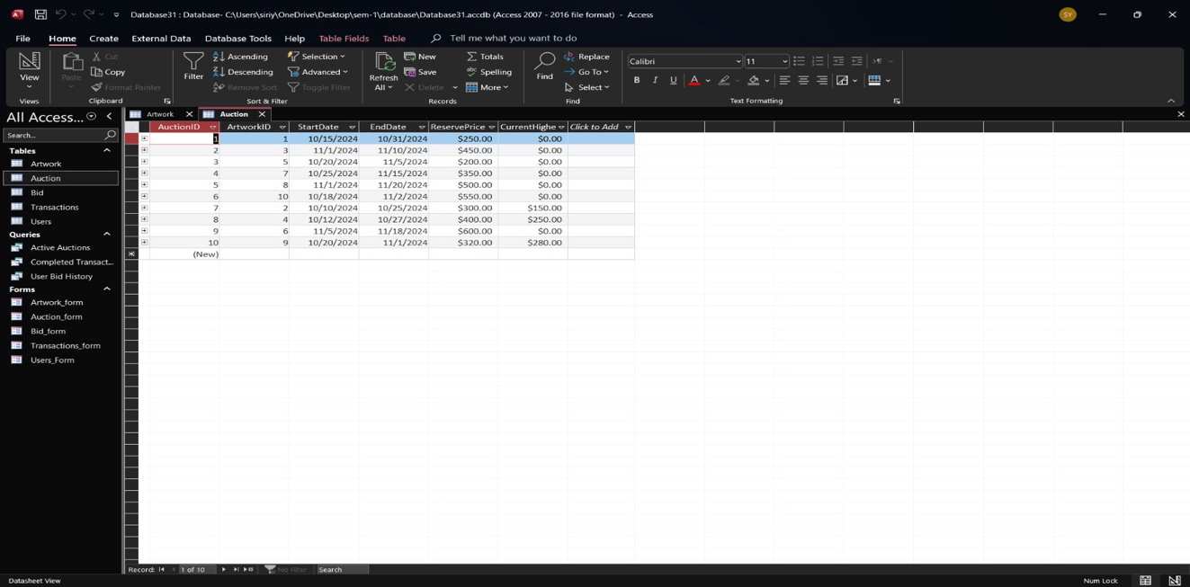

Bid Datasheet:

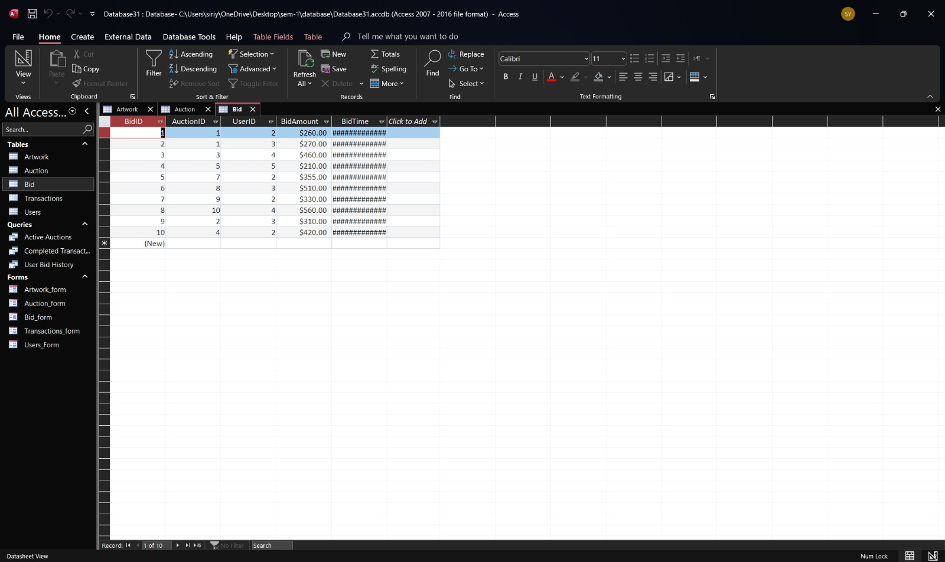

Transactions Datasheet:

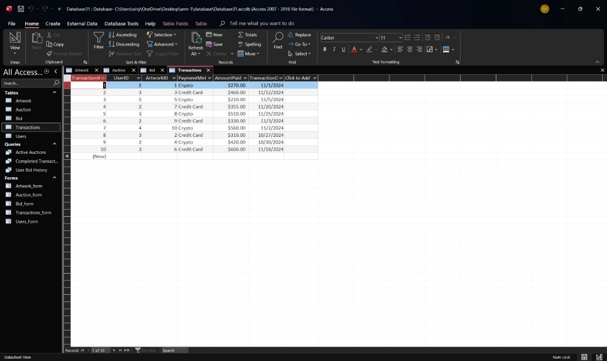

Users Datasheet:

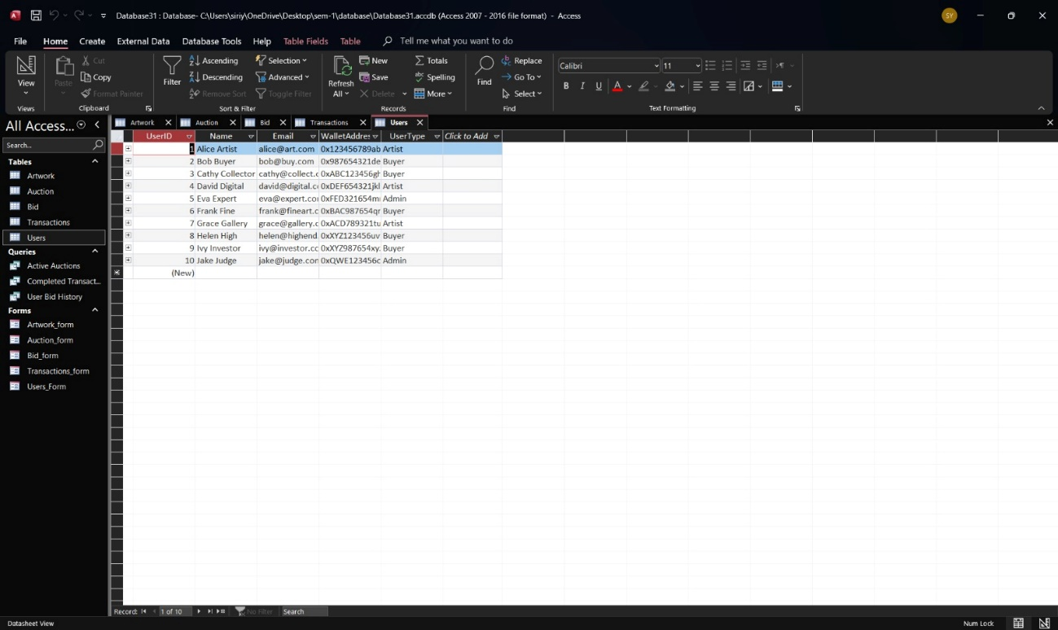

Design Tables

Artwork Table
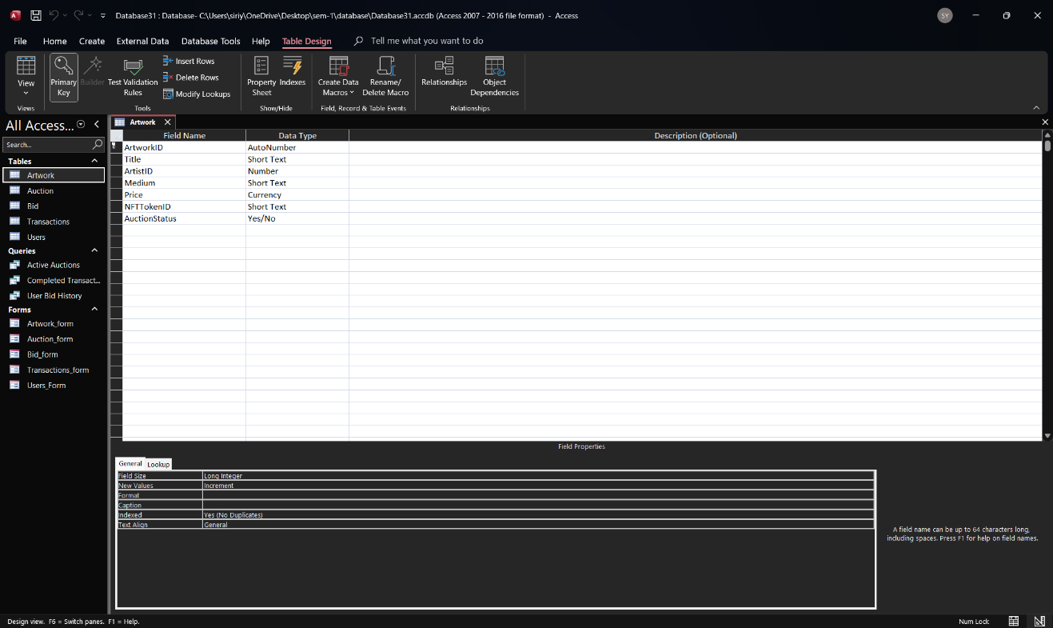
Auction Table
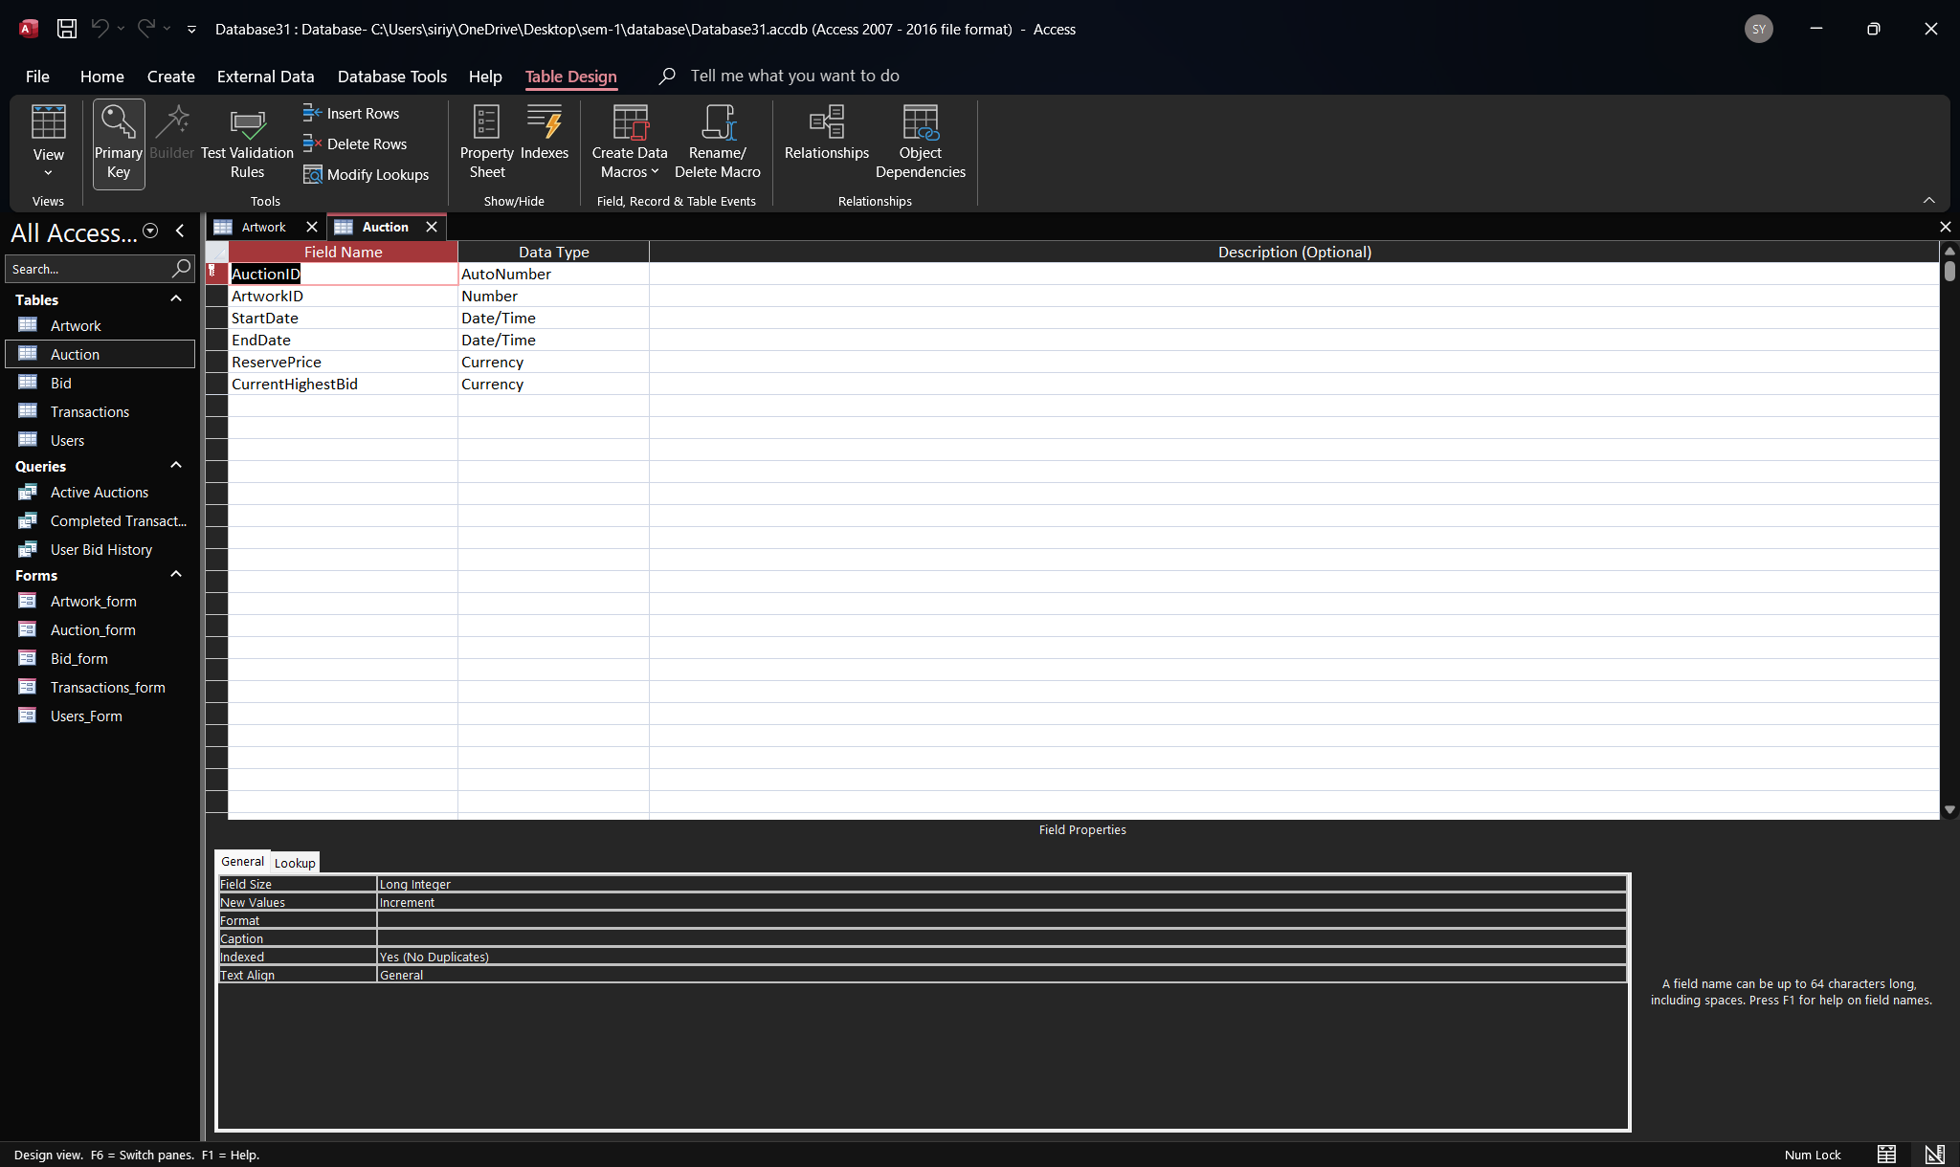
Bid Table
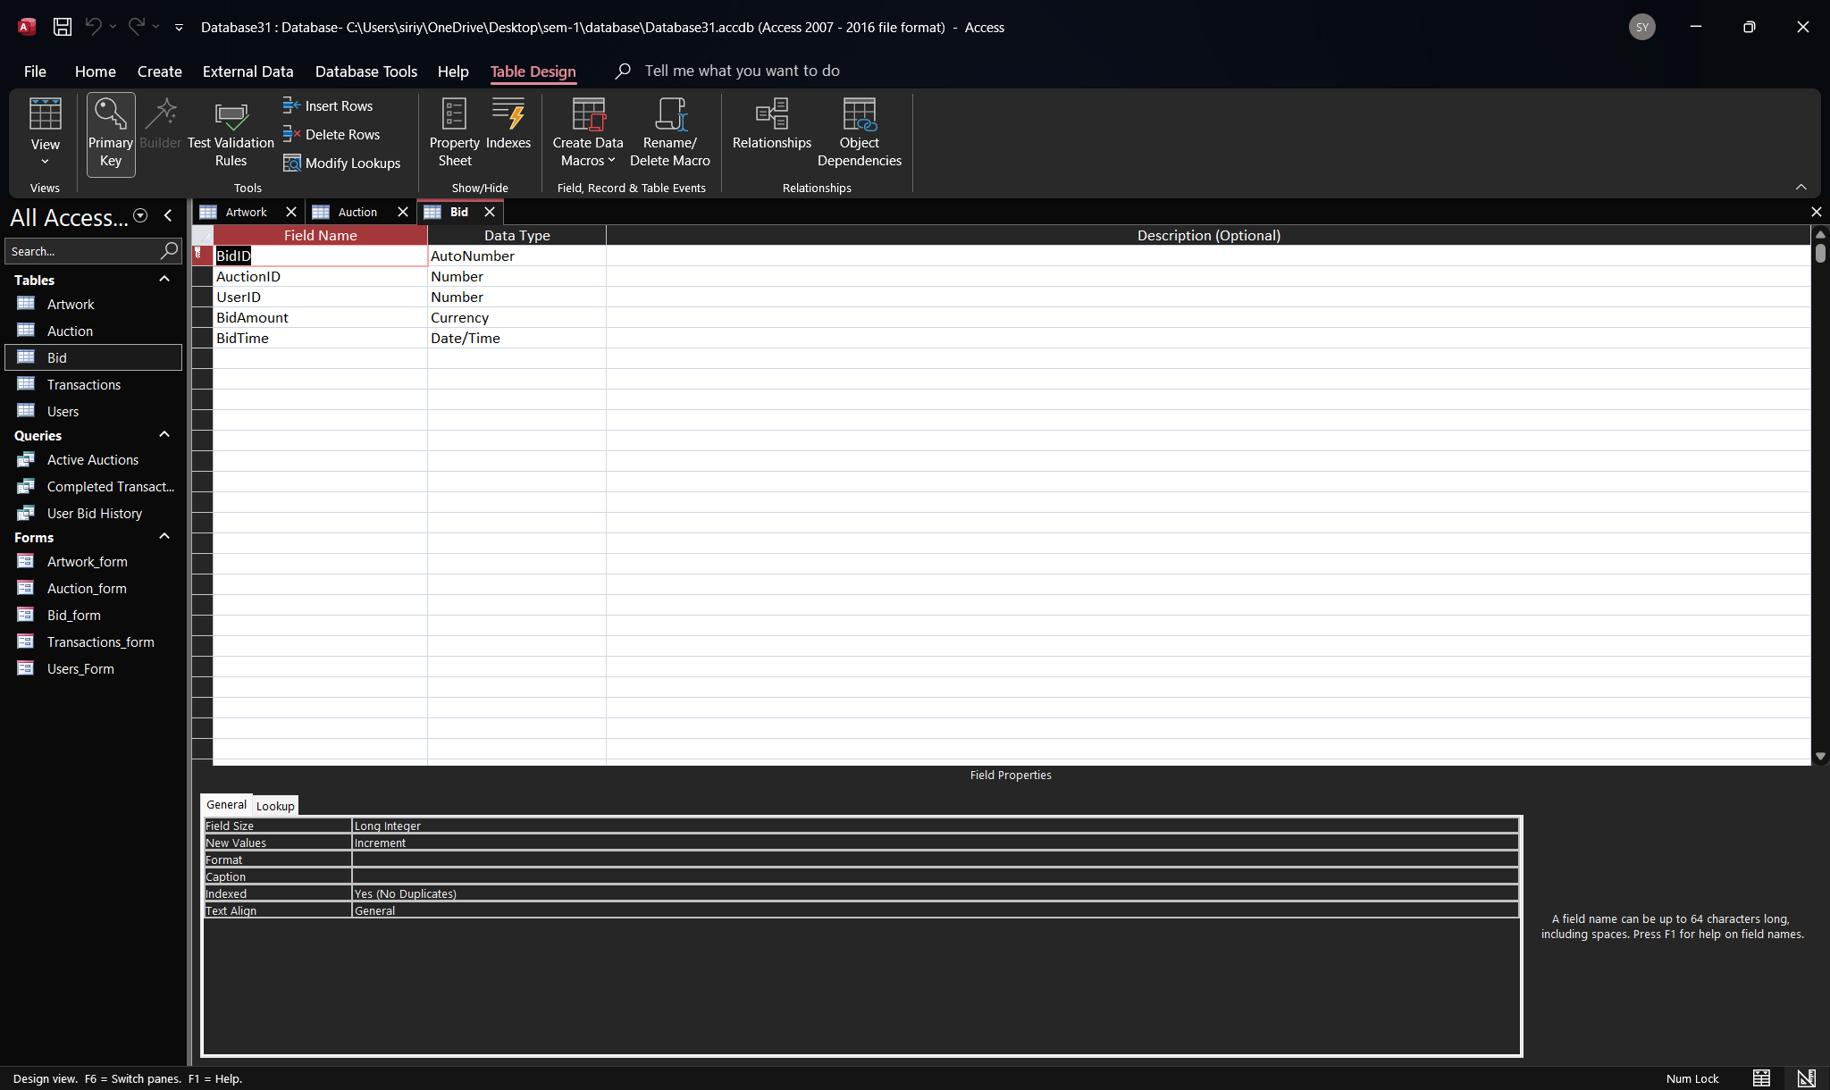
Transaction Table
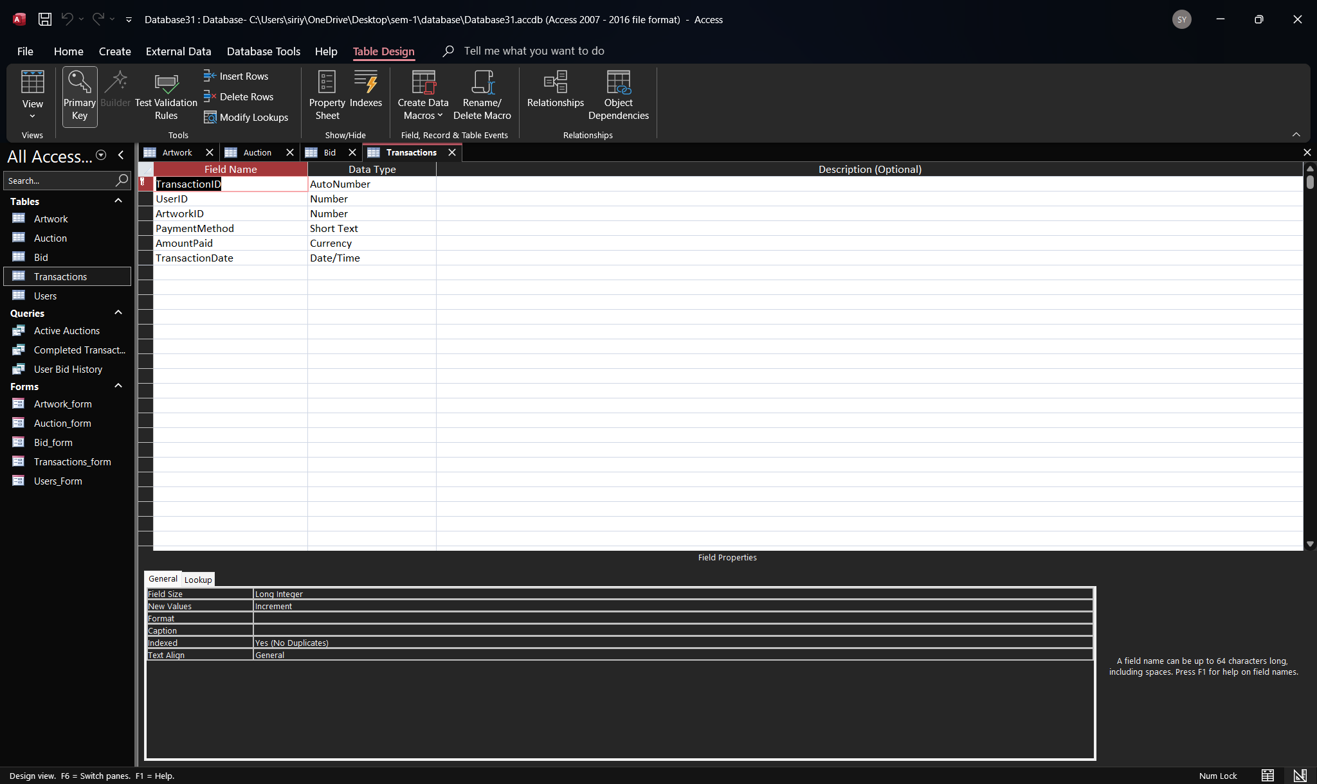

Users Table
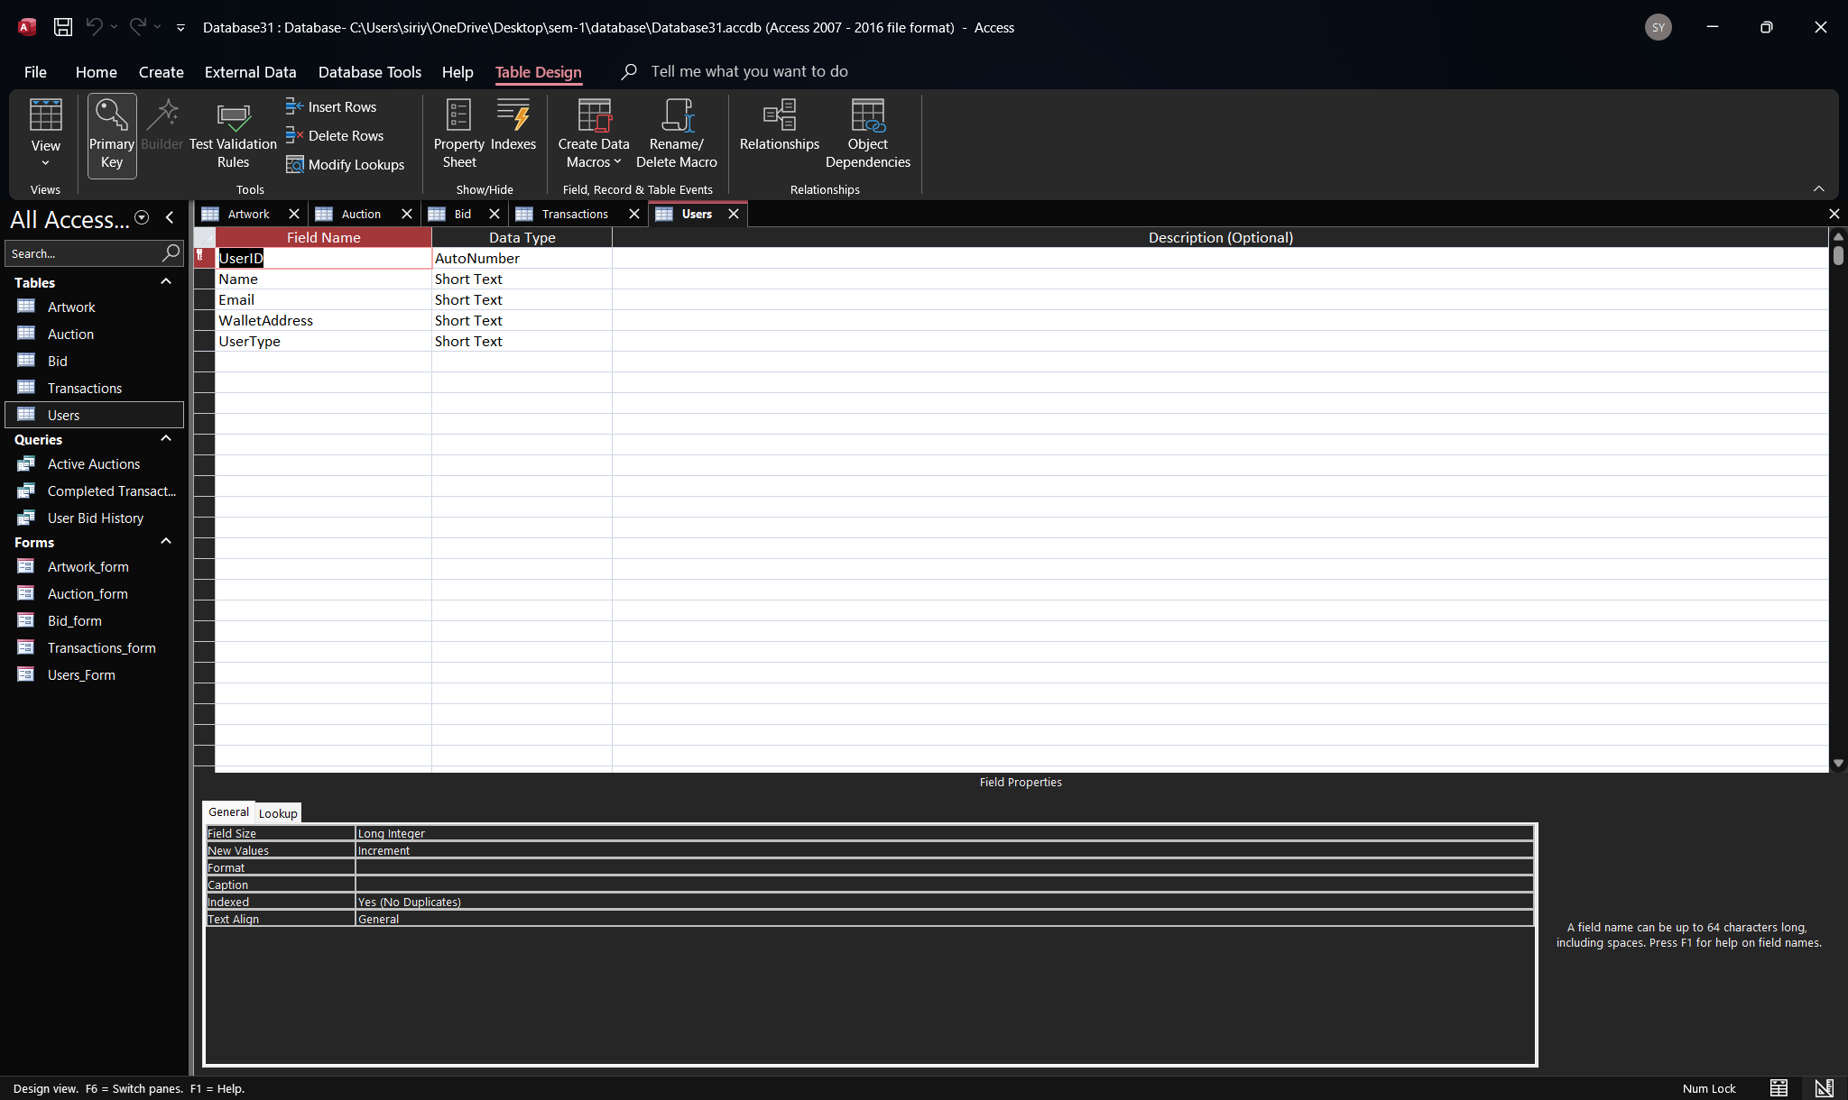

Forms
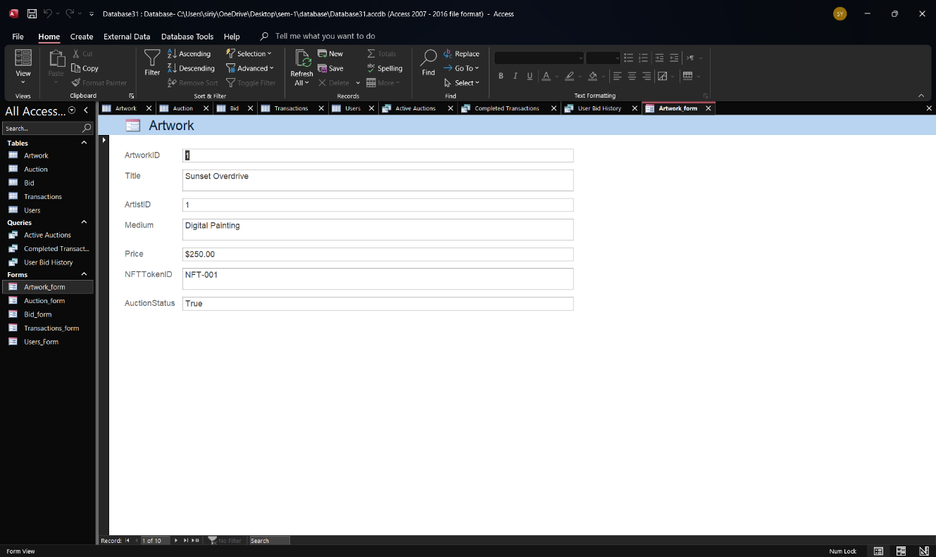
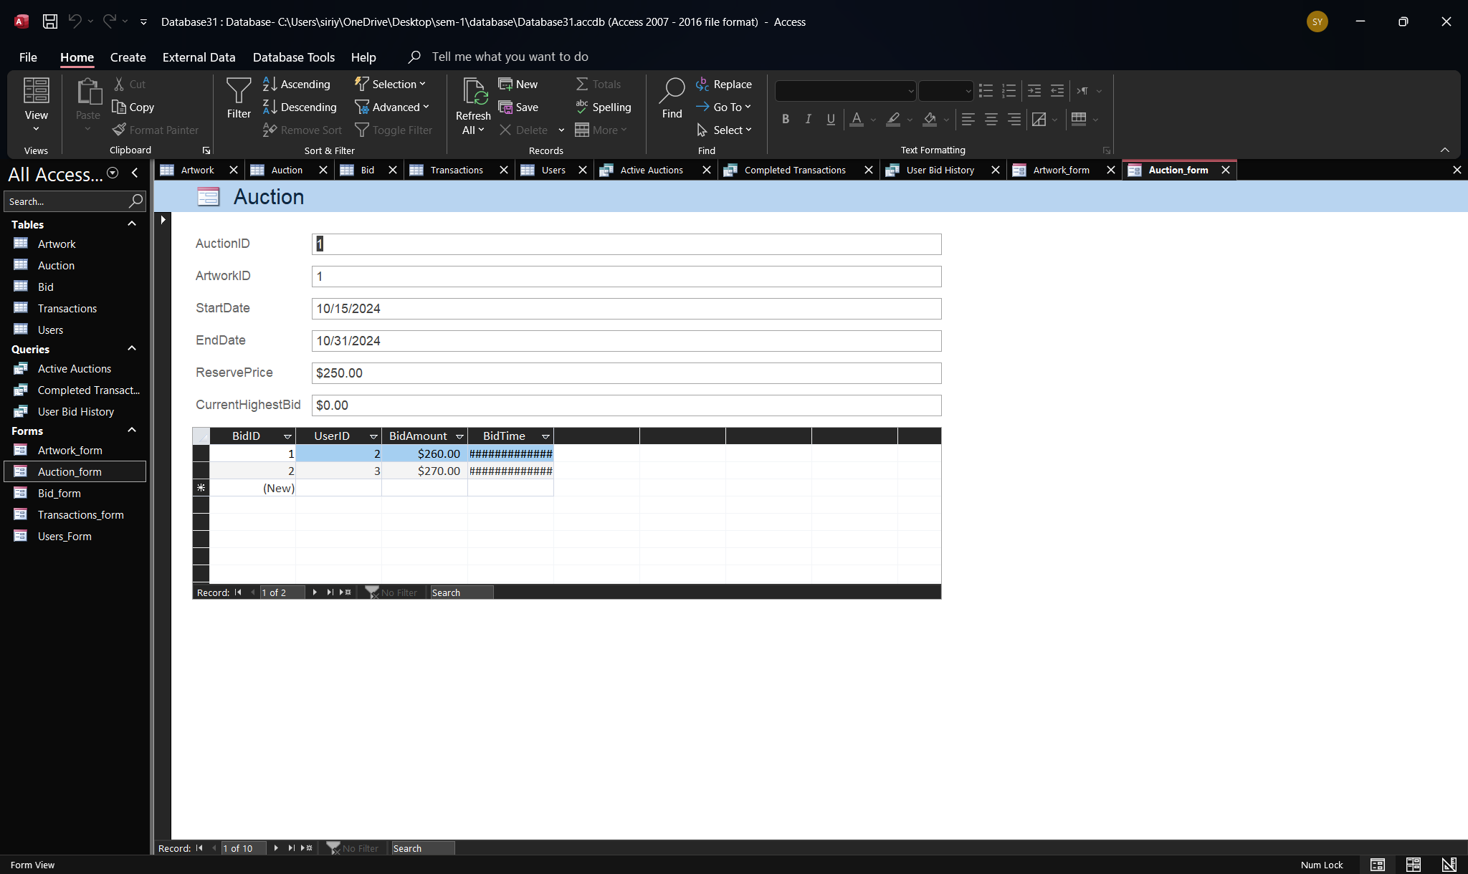
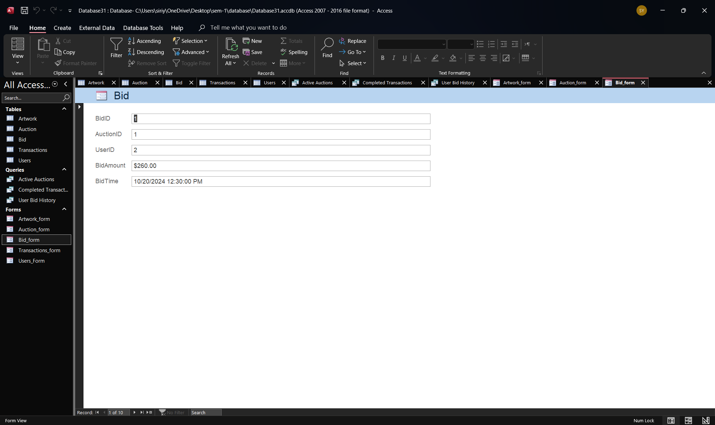
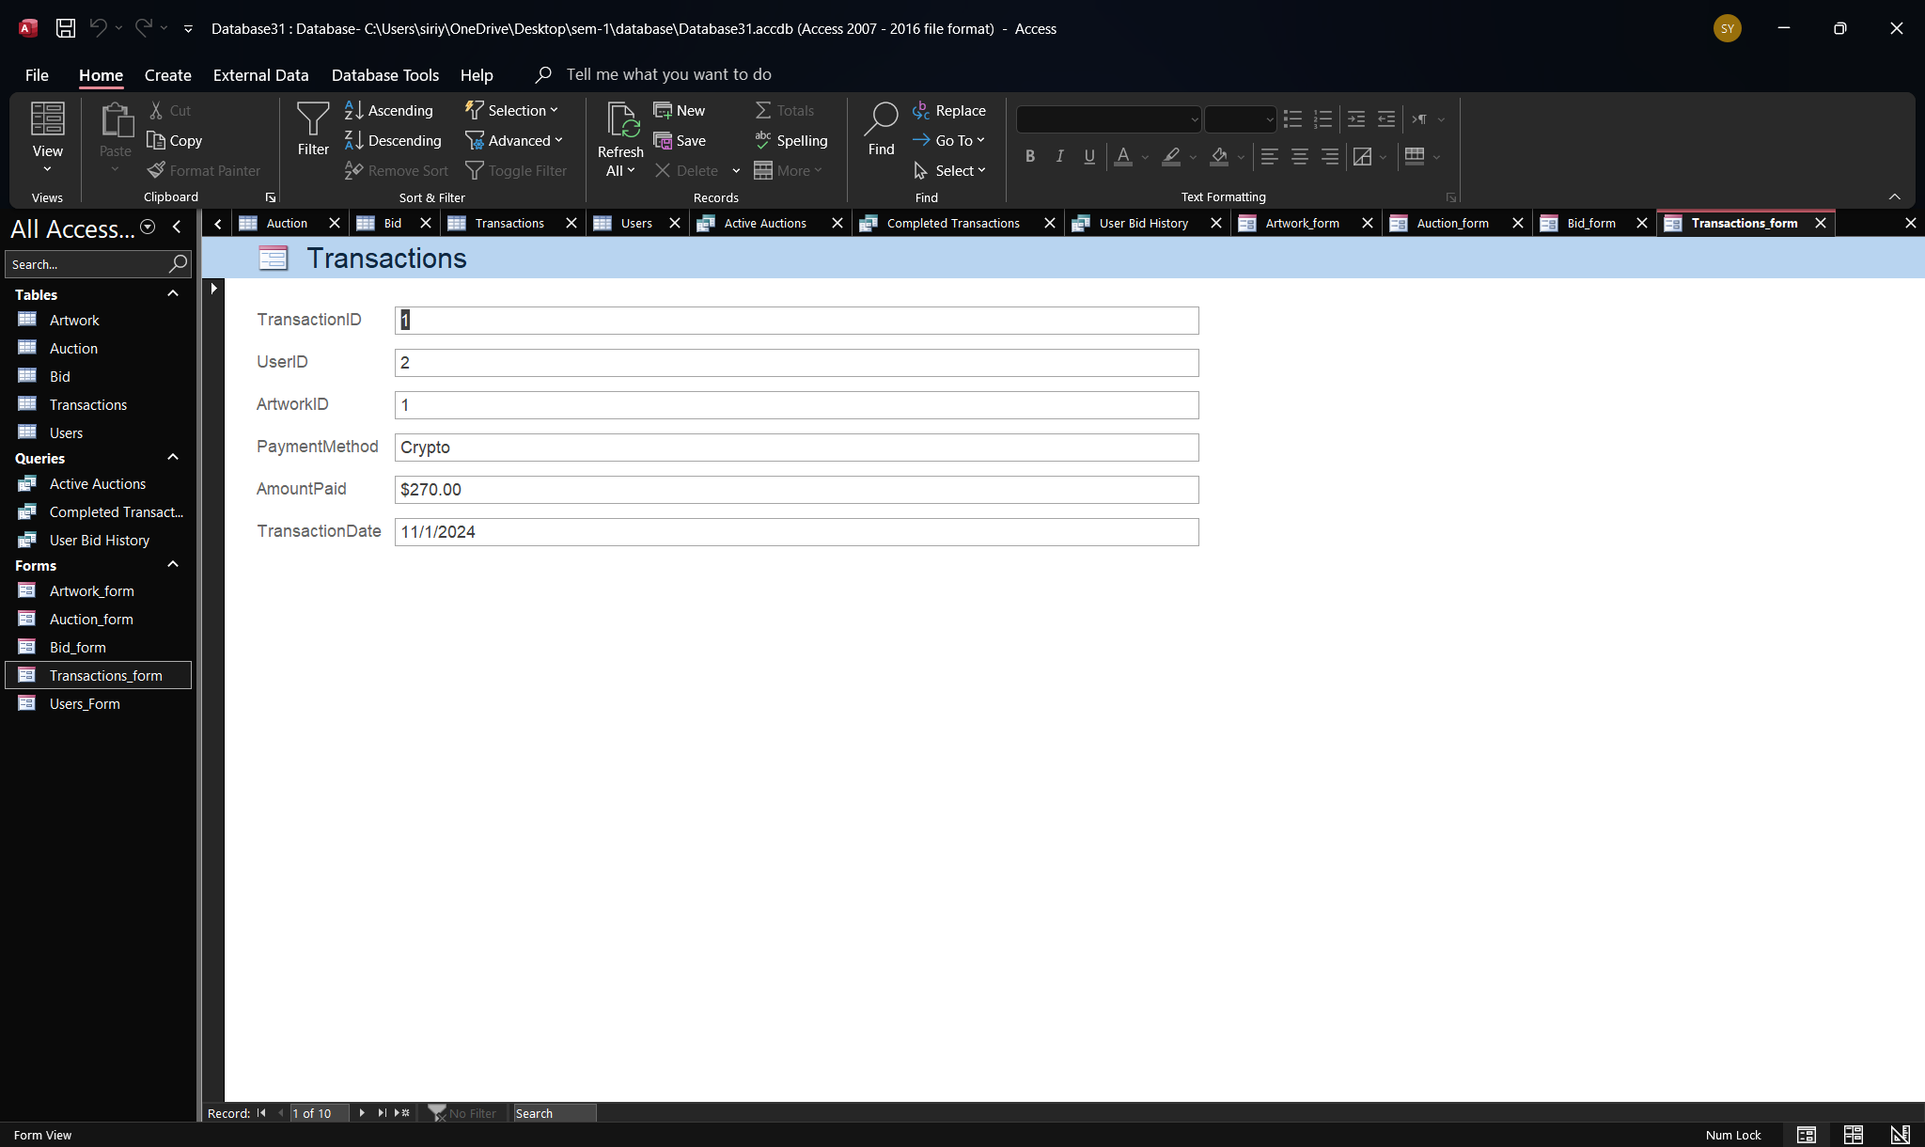
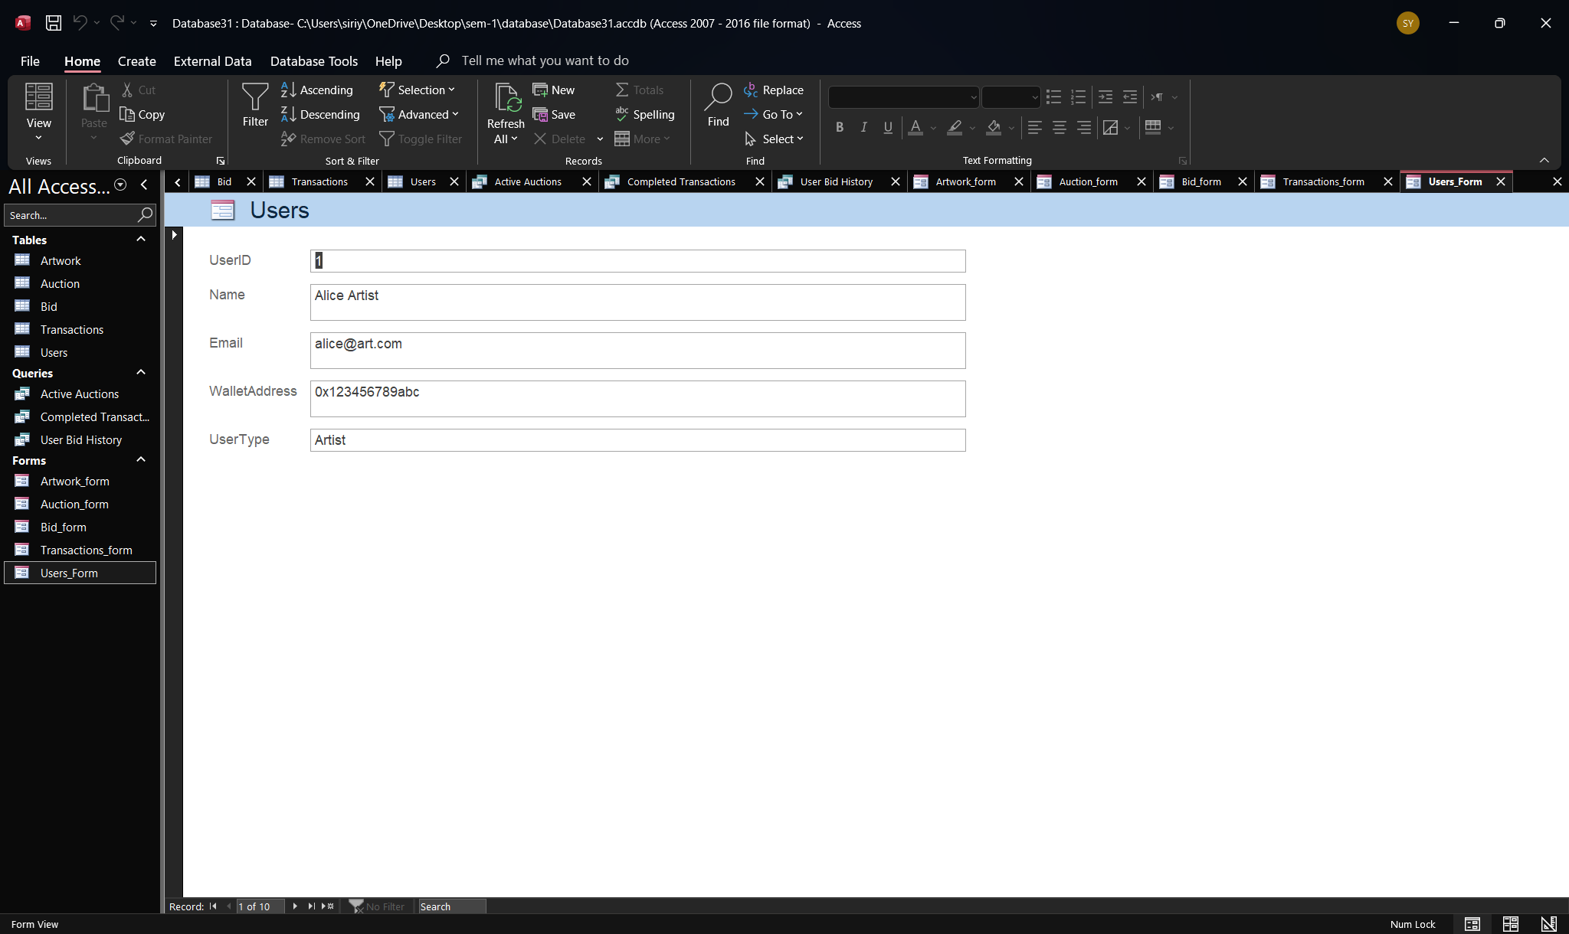

Queries
- SELECT Auction.AuctionID, Artwork.ArtworkID, Artwork.Title, Auction.StartDate, Auction.EndDate, Auction.CurrentHighestBid FROM Artwork INNER JOIN Auction ON Artwork.ArtworkID = Auction.ArtworkID;
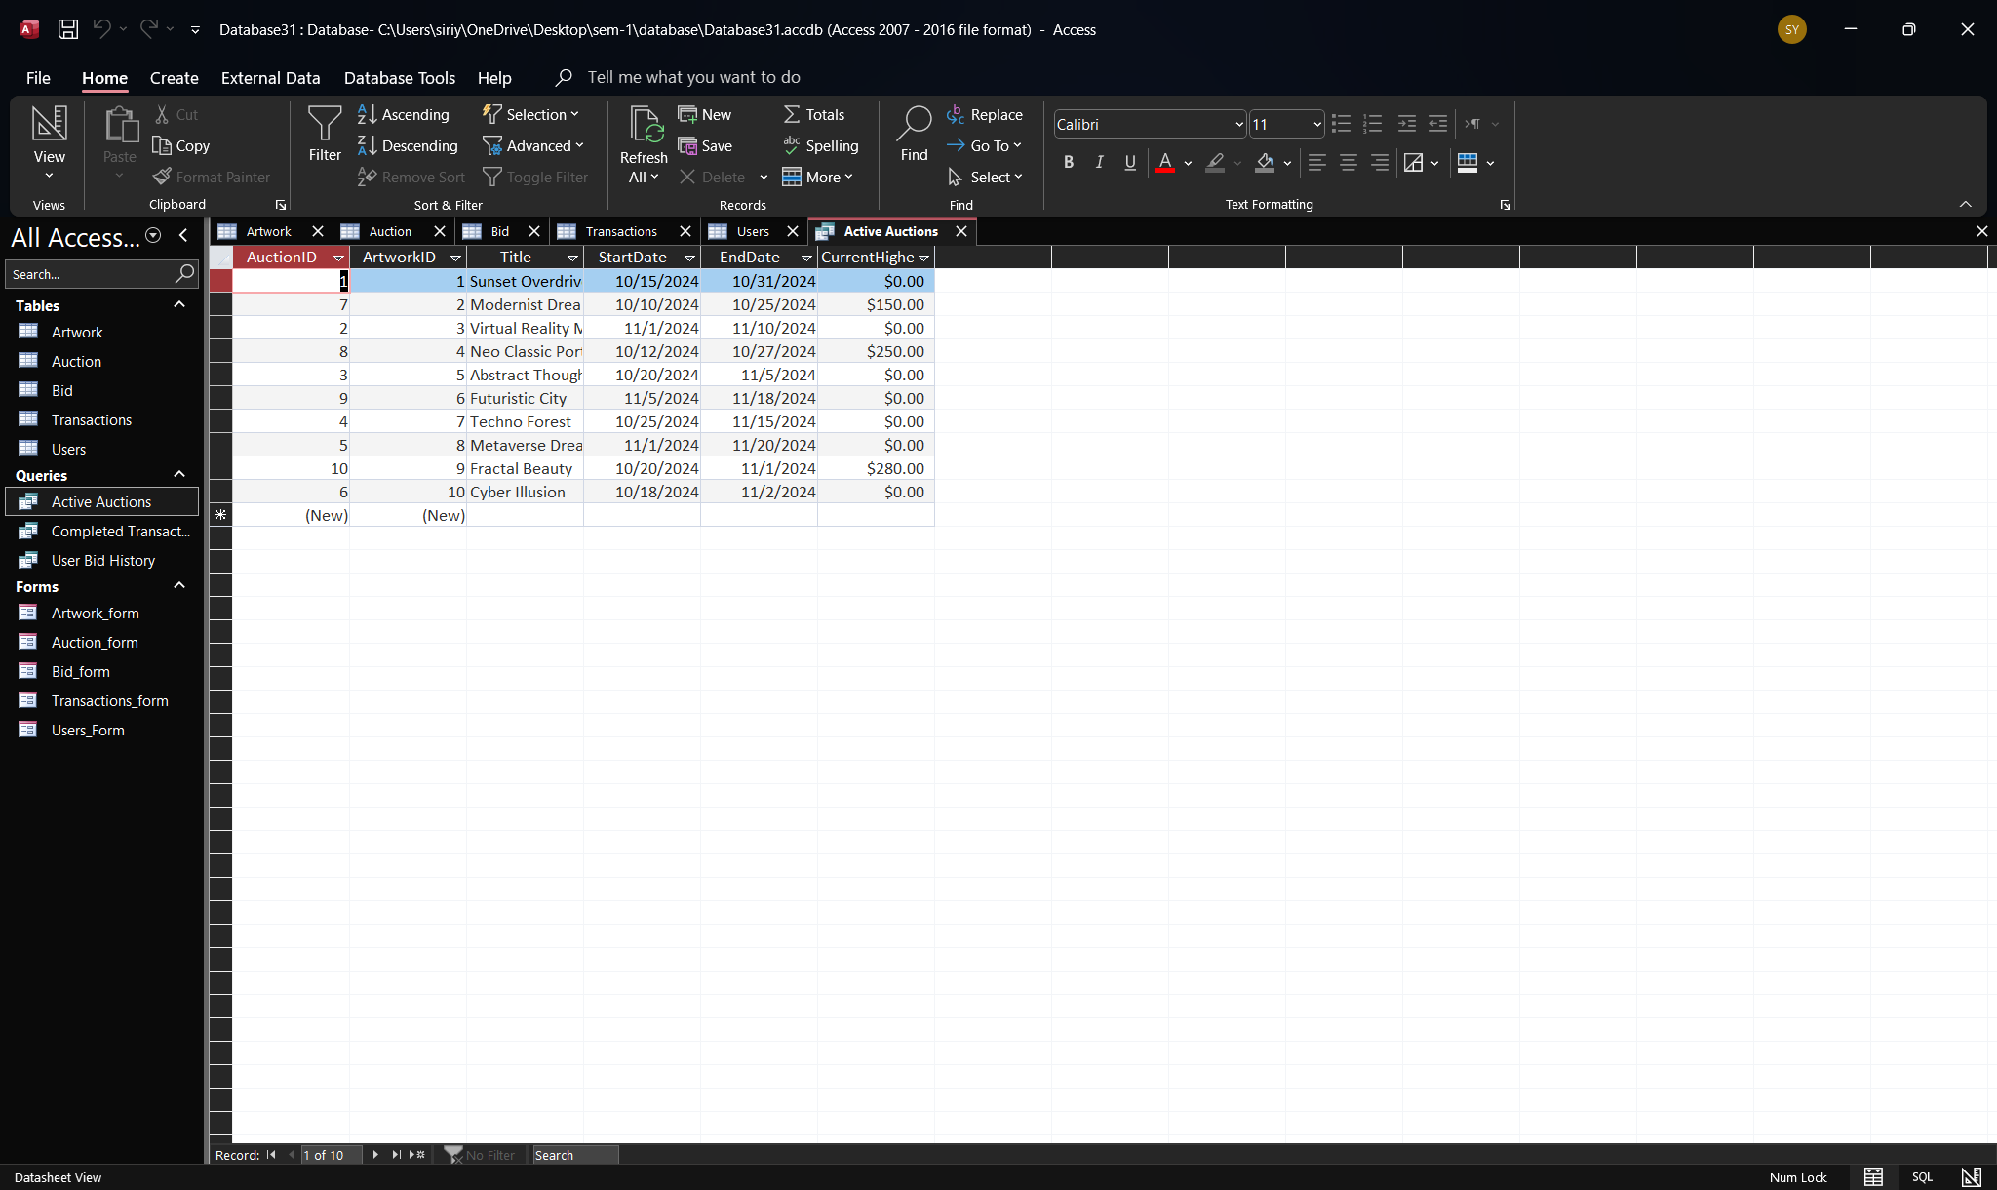

- SELECT Transactions.TransactionID, Transactions.UserID, Artwork.ArtworkID, Transactions.AmountPaid, Transactions.TransactionDate FROM Artwork INNER JOIN Transactions ON Artwork.ArtworkID = Transactions.ArtworkID
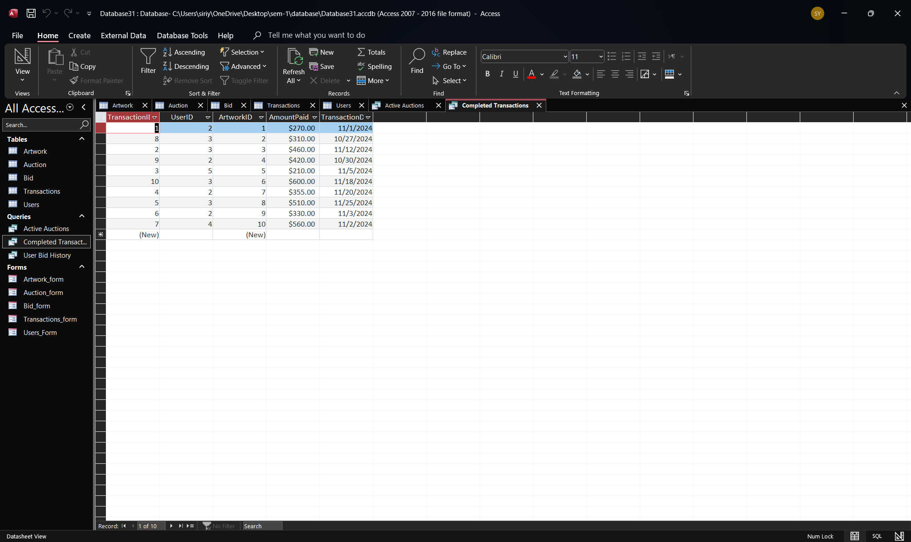

- SELECT Bid.BidID, Bid.AuctionID, Bid.BidAmount, Bid.BidTime, Bid.UserID, Auction.ArtworkID FROM Auction INNER JOIN (Users INNER JOIN Bid ON Users.UserID = Bid.UserID) ON Auction.AuctionID = Bid.AuctionID
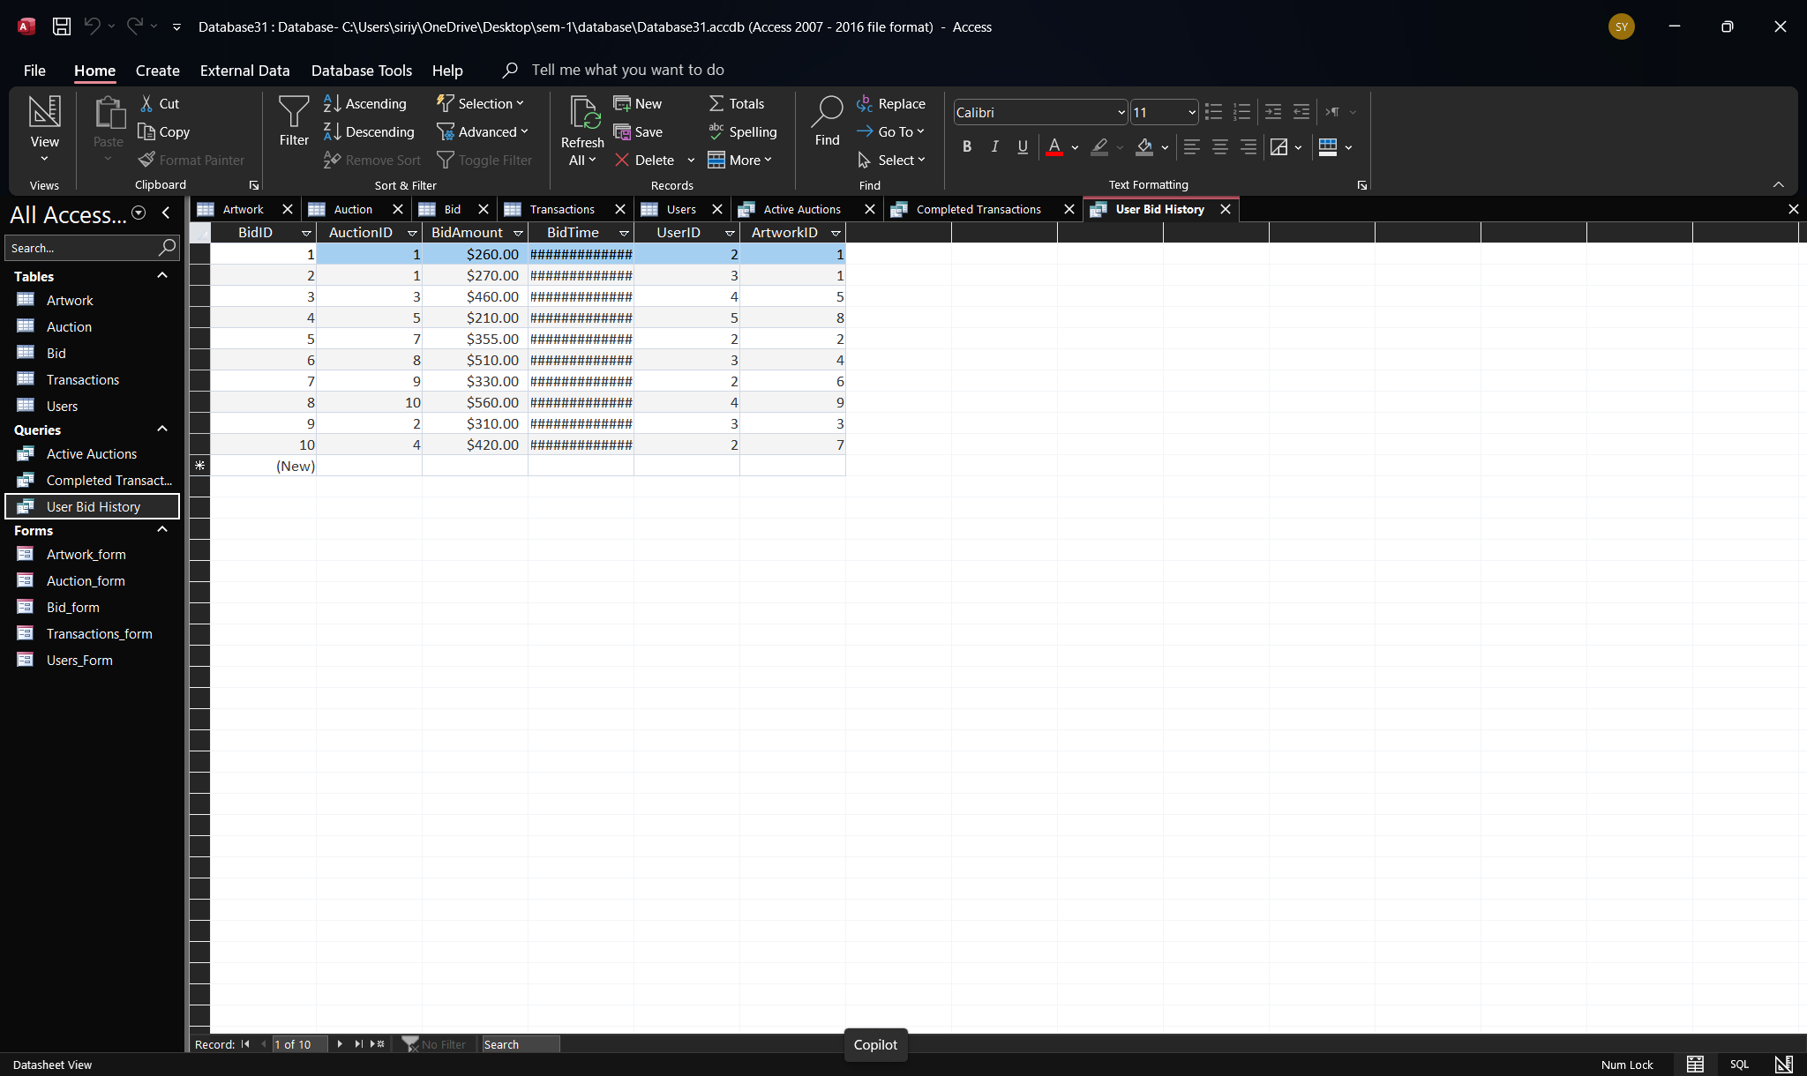

References and Citations

Textbook on Database Design:

- Kroenke, D. M., & Auer, D. J. (2015). Database Processing: Fundamentals, Design, and Implementation (14th ed.). Pearson Education.

Crow's Foot Notation and Database Systems:

- Connolly, T., & Begg, C. (2015). Database Systems: A Practical Approach to Design, Implementation, and Management (6th ed.). Pearson Education.

Database Management in Auctions:

- Lindner, G., & Wiedmann, K.-P. (2015). Data management in electronic auctions: challenges and implications. Journal of Strategic Information Systems, 24(1), 51-70. https://doi.org/10.1016/j.jsis.2014.09.002

NFTs and Digital Art:

- Ante, L. (2021). The Non-fungible Token (NFT) market and its relationship with Bitcoin and Ethereum. FinTech, 12, 5-21.

Relational Database Theory:

- Elmasri, R., & Navathe, S. B. (2010). Fundamentals of Database Systems (6th ed.). Pearson.

